Miami University
Virtual Security Operations Center
vSOC Senior Design Capstone
Master Technical Documentation
CYB 449 — Spring 2026

Field | Details
Project Name | vSOC — Virtual Security Operations Center
Institution | Miami University
Course | CYB 449 Senior Design Capstone
Team Members | Evan Ellsworth, Jack Klein, Parker Sherman, Jay Hedding
Advisor / Sponsor | James Walden
Academic Year | 2025-2026
Last Updated | 05/06/26
Version | 1.0

1. Project Overview

1.1 Purpose & Scope
The Miami University vSOC is a fully virtualized Security Operations Center built on a Proxmox hypervisor environment. It is designed to simulate real-world enterprise security monitoring, incident detection, and response workflows for academic purposes, including hands-on demonstrations of attack chains, detection pipelines, and automated remediation.

1.2 Architecture Summary
The lab is organized around a Proxmox node hosting all virtual machines and containers. Network segmentation is enforced by OPNsense acting as the perimeter firewall. Wazuh serves as the central SIEM/XDR platform. Suricata provides inline network intrusion detection. Ansible and Terraform handle infrastructure automation and reproducibility. Metasploitable 3 asks as a victim host to conduct attacks. Cowrie is used as a honey pot as another victim host.

1.3 Team Roles & Responsibilities
Team Member | Primary Responsibility
Jack Klein | Virtual Infrastructure & automation
Jay Hedding | Victim hosts and attack simulations
Evan Ellsworth | Wazuh dashboard designs and demos
Parker Sherman | Documentation and GitHub manager

2. Proxmox Infrastructure

2.1 Proxmox Node Overview
Parameter | Value
Node Name | pm2
Proxmox Version | 9.1.1
Host IP | 172.17.0.3
Access | Via Miami University school VPN
Web UI Port | 8006
Storage Backend | local-lvm, local, cifs
CPU | 4 CPUs
RAM | 32 GB
Disk | 4TB
Platform | CEC test environment – managed by Dr. Campbell

2.2 VM Inventory
Template ID | VM ID | VM Name | OS | IP Address | Role / Purpose | Subnet
1000 | 1001 | Ansible-terraform lxc | Ubuntu 25.04 | 172.17.0.204 | IT automation control center, Standardized environment | wan
1400 | 1401 | opnsense-swan | FreeBSD | Bootstrap: 172.17.0.228  Ultimate: user-controlled | Firewall, DHCP server, IDS platform | Wan, lan
1110 | 1111 | wazuh-dashboard | Ubuntu 25.10 | Cloud-init static ip | SIEM / XDR Manager | wan
1100 | 1101 | wazuh-indx-mngr | Ubuntu 25.10 | Cloud-init static ip | Wazuh indexer & manager | lan
1350 | 1351 | ms3-win2k8  (wazuh agent intalled) | Rapid7 Metasploitable 3 win2k8 | DHCP | Vulnerable Target | lan
2000 | 2001 | cowrrie-demo | Ubuntu 25.10 | Cloud-init static ip | SSH Honeypot | lan
1200 | 1201 | kali-wan | Kali | Cloud-init static ip | Red Team / Attack Platform | wan
1200 | 1202 | kali-lan | kali | Cloud-init static ip | Red Team / Attack Platform | lan
1500 | 1501 | pentest | Ubuntu 25.10 | Cloud-init static ip | AI pentest agent | lan
2000 | N/A | Ubuntu ls no-agent template | Ubuntu 25.10 | N/A | Strict Template of Ubuntu Liveserver, with cloud-init enabled. Serves as a base template for further development of new golden images | N/A

2.3 Network Bridges
Bridge | Purpose | CIDR
Vmbr0 (unmanaged dependency) | Miami-Routable subnet with independent upstream gateway  WAN POOL | 172.17.0.0/24
vmbr10 | Internal Lab Network  LAN POOL | 172.30.0.0/24

3. OPNsense Firewall

3.1 Overview
Opnsense is the only bridge from routable space to the internal network. The router runs a dhcp server, Suricata IDS, and performs standard routing requirements.

Opnsense provides a feature-rich web API for data retrieval and state modification.

3.2 OPNsense Configuration
Parameter | Value
Version | 26.1.2_5
WAN Interface | Vtnet0: 172.17.0.228/24 (initial state)
LAN Interface | User Defined
Admin UI | https://172.17.0.228
Admin Credentials | User root passwd 123456789 (Should Be Changed In use)

3.3 Interfaces
WAN (vtnet0) -> v4: 172.17.0.228/24
LAN (vtnet1) -> v4: user-configurable

Vtnet0 has a hardcoded static bootstrap IP in order to provide ansible with an ssh endpoint. With ansible, a customized config.xml is inserted that remaps both interface addresses to user defined points. In general, the template bootstrap IP should be remapped for migration, and the IP removed from the dhcp range.

Alternative configuration: Vtnet0 could be set to DHCP inside of the template, but this would then require adding a route to query the DHCP server for the ip. This adds ownership of the upstream gateway to the list of dependencies, so we decided against it.

3.4 Firewall Rules

3.4.1 WAN Rules
Essentially allow all in, blocks virusprot, bogons, and port 0.

3.4.2 LAN Rules
Similarly allows all egress. Blocks virusprot

3.4.3 Inter-VLAN / Inter-Segment Rules
In this architecture, SIEM telemetry is not blocked behind a vlan.

3.5 NAT Configuration
Router default MASQERADEs Egress:
Automatic outbound NAT rule generation
(no manual rules can be used)

3.6 Suricata on OPNsense
Suricata IDS/IPS is deployed directly on OPNsense as a plugin, providing inline inspection on the LAN interface. See Section 6 for full Suricata documentation. Logs are configured in ansible and sent to wazuh over syslog.

4. Wazuh SIEM / XDR

4.1 Overview
Wazuh is the central SIEM and EDR platform for the vSOC. It aggregates logs and alerts from all agents deployed across VMs in the lab, correlates events using built-in and custom detection rules, and provides dashboards via its integrated OpenSearch/Kibana frontend.

4.2 Wazuh Manager Configuration
Parameter | Value
Wazuh Version | 4.14
Manager IP | Static cloud-init IP
Web UI (Dashboard) | https://[cloud-init static ip]:443
API Port | 55000
Agent Communication Port | 1514 (TCP/UDP)
Agent Enrollment Port | 1515
Install Method | Manual (ansible-automated deployment)

4.3 Agent Deployment

4.3.1 Deployed Agents
Agent Name | Host
cowrie | cowrrie-demo
metasploitable | ms3-win2k8

4.4 Detection Rules

4.4.1 Built-in Rule Sets Enabled
The following default Wazuh rule groups are active with no custom modifications:

Syslog: general system log parsing
Web: web server access and error log detection
Windows: Windows event log rules (used for Metasploitable3-Win)
Fim: File Integrity Monitoring alerts
Vulnerability-detector: CVE correlation against installed packages
mitre: MITRE ATT&CK technique mapping for triggered alerts
Ossec: core OSSEC-based rules for authentication, rootcheck, and policy monitoring

4.4.2 Custom Rules
No custom rules were written for this deployment. All detection logic relies on built-in Wazuh rule sets.

4.4.3 Active Responses
No active response scripts are configured in this deployment. The vSOC operates in a detection and monitoring capacity only, but does have the capabilities to respond via EDR rulesets

4.5 File Integrity Monitoring (FIM)
FIM is enabled by default on our 2 agents, metasploitable and cowrie

4.6 Log Sources & Decoders
Cowrie logs via a local file block in ossec.conf, Suricata logs via eve.json from OPNsense, and host-based events from Wazuh agents located on each host

4.7 Wazuh Dashboards
We have 2 main dashboards to observe data on. The first one is Suricata Overview, which displays data from our Suricata NIDS. It will tell you information such as the different types of alerts generated, alert severity, and top 5 targeted IPs. Our second dashboard is for our Cowrie honeypot. It will show all of the commands typed into the machine, as well as any login attempts made. There is also graphs for events timeline, types of events, and event type distribution.

5. Cowrie SSH Honeypot

5.1 Overview
Cowrie is a medium-to-high interaction SSH and Telnet honeypot designed to log brute-force attacks and shell interaction performed by attackers. In the vSOC, Cowrie is deployed to capture attacker behavior, generate realistic telemetry, and forward logs to Wazuh for correlation.

5.2 Deployment Details
Parameter | Value
Host VM | 2001 cowrie-demo
Host OS | Ubuntu 22.04
Host IP | 172.17.0.236
Cowrie Listen Port | 2222
Deployment Method | virtualenv
Log Output Path | /home/cowrie/cowrie/var/log/cowrie/

5.3 Log Forwarding to Wazuh
Cowrie JSON logs are forwarded to the Wazuh manager via a Wazuh agent running on the same host, using a custom localfile configuration.

6. Suricata NIDS

6.1 Overview
Suricata is deployed as a Network Intrusion Detection System (NIDS) on OPNsense, inspecting traffic on the LAN interface. Alerts are forwarded to Wazuh via the eve.json log format.

6.2 Configuration
Parameter | Value
Suricata Version | 172.17.0.228
Deployment | OPNsense plugin
Inspection Interface | LAN
Rule Sets Enabled | Emerging Threats Open
Alert Log | eve.json
Log Path | /var/log/suricata/eve.json

6.3 Rule Sets

6.3.1 Enabled Rule Sets

6.3.2 Custom Rules
No custom Suricata rules were written for this deployment. The ET Open ruleset provided sufficient coverage for the attack scenarios demonstrated, including EternalBlue/MS17-010 SMB exploitation and SSH brute-force activity against the Cowrie honeypot.

6.4 Wazuh Integration
Suricata alert forwarding to Wazuh is handled via syslog from OPNsense. The eve.json output log is configured via Ansible and forwarded over syslog to the Wazuh manager. The Wazuh manager ingests these alerts using the built-in Suricata decoder, which parses EVE JSON fields including src_ip, dest_ip, alert.signature, alert.severity, and alert.signature_id. Alerts are indexed under the wazuh-alerts-* pattern and are visible in the Suricata Overview dashboard. All hosts with Wazuh agents forward logs via syslog as well.

7. Metasploitable 3 (Vulnerable Targets)

7.1 Overview
Metasploitable 3 provides intentionally vulnerable machines used as targets for attack demonstrations and SIEM/NIDS detection validation. Both Windows and Linux variants are deployed in the vSOC lab.

7.2 Metasploitable3 Windows
Parameter | Value
VM IDs | 113 (primary), 117 (clone)
OS | Windows Server 2008 R2
IP Address | 172.26.1.13
Build Method | Cloud-Image import
Wazuh Agent | Installed
Key Vulnerabilities | MS17-010 (EternalBlue), SMBv1, open RDP, (see ms3 docs)
Cloud-Image Provider | Rapid7

7.2.1 Key Services & Vulnerabilities
- SMBv1 enabled — exploitable via MS17-010 / EternalBlue
- RDP (port 3389) — brute-forceable
- WampServer (Apache/MySQL/PHP) — vulnerable web stack

7.4 Attack Chain: EternalBlue / MS17-010 Demo
The primary attack demonstration uses EternalBlue against the Metasploitable3 Windows target from a Kali Linux attacker VM, culminating in a PowerShell ransomware simulation.

7.4.1 Attack Steps
Step | Action
1 | Scan target
2 | Load exploit module
3 | Set target & payload
4 | Execute exploit
5 | Ransomware simulation

7.4.2 PowerShell Ransomware Simulation

See soc_demo_runbook.docx

8. Terraform Infrastructure as Code

8.1 Overview
Terraform is used to automatically manage the state of the network infra and VMS. Largely, this is implemented as cloning dedicated golden images by VM ID. The Bpg/proxmox Terraform provider is used to interface with the Proxmox API. In essence, terraform provides the interface for proxmox operations.
The general UP workflow is to cd into terraform/network-init, then terraform apply, then perform intermediate configuration via ansible. Next cd into terraform/main, terraform apply, and finish configs with ansible.

This is all wrapped by a shell script.

8.2 Repository Structure
terraform
|-- keyfile.pem -> /root/group.pub
|-- main
| |-- attackers.tf
| |-- ms3.tf
| |-- providers.tf -> ../providers.tf
| |-- terraform.tfstate
| |-- terraform.tfstate.backup
| |-- terraform.tfvars -> ../terraform.tfvars
| |-- variables.tf -> ../variables.tf
| `-- wazuh.tf
|-- network-init
| |-- network_resources.tf
| |-- opnsense.tf
| |-- providers.tf -> ../providers.tf
| |-- terraform.tfstate
| |-- terraform.tfstate.backup
| |-- terraform.tfvars -> ../terraform.tfvars
| `-- variables.tf -> ../variables.tf
|-- providers.tf
|-- terraform.tfstate
|-- terraform.tfstate.backup
|-- terraform.tfvars -> /root/terraform.tfvars
|-- tfschema.json # JSON Schema for bgp/proxmox resources
|-- variables.tf

8.3 Provider Configuration
Parameter | Value
Provider | bpg/proxmox
Provider Version | ~> 0.99
Proxmox API URL | https://172.17.0.4:8006/
Auth Method | API token / username+password [kleinjw2@miamildap!terraform=**secret**]]
State Backend | Local binary

8.4 Resources Defined

8.4.1 VM Resources
Resource Type | proxmox_virtual_environment_network_linux_bridge:
- Lan_bridge
Resource Type | proxmox_virtual_environment_vm:
- Opnsense
- Kali-wan
- Kali-lan
- Pentest
- Ms3-win
- Wazuh-indx-mngr
- Cowrie
- wazuh-dashboard

8.4.2 Variables
variable "proxmox_api_token" {
description = "Proxmox API token in format kleinjw@miamildap!tokenid=secret"
sensitive = true
}
variable "proxmox_ssh_keypath" {
description = "Root SSH key path for pm2"
sensitive = true
}
variable "proxmox_node" {
description = "name of our working node"
}
variable "wan_bridge" {
description = "the name of the wan bridge"
}
variable "lan_bridge" {
description = "the name of the lan bridge"
}

8.5 Usage

8.5.1 Common Commands
Use terraform wrapper shell script, or use terraform apply in network-init then opnsense config in ansible, then terraform apply in main.

terraform init # Initialize providers
terraform plan # Preview changes
terraform apply # Apply changes
terraform destroy # Tear down resources

8.6 Known Issues & Notes
The BPG provider github is a little bit of a mess before the 1.0 release. Referring to tfschema.json to verify valid syntax is important to properly defining resources.

Sometimes terraform apply in the main directory can time out due to copying hundred gig discs. Idempotency means the solution is to run terraform apply again and it should work.

9. Ansible Configuration Management

9.1 Overview
While terraform interfaces directly with proxmox, and well-manages machine state, detailed configuration is still required. This is delegated to ansible, which uses ssh endpoints to directly modify machines, wrapping shell individual commands in a declarative yml UI.

In this project, ansible is generally called after a machine is brought up to overwrite config files, interface with the opnsense API, and handle service states/reloads

9.2 Repository Structure
ansible
|-- ansible.cfg
|-- ansibleapi.json
|-- collections
| `-- ansible_collections
| `-- ansibleguy.opnsense-1.2.16.info
| `-- GALAXY.yml
|-- files
| |-- config.yml.j2
| |-- filebeat.yml.j2
| |-- netplan-route.yaml.j2
| |-- opensearch.yml.j2
| |-- opensearch_dashboards.yml.j2
| |-- opnsense-suricata.conf.j2
| |-- ossec.conf.j2
| |-- wazuh-alert.json
| |-- wazuh-certs-tool.sh
| |-- wazuh-dash.ndjson
| `-- wazuh.yml.j2
|-- group_vars
| |-- opnsense.yml
| |-- opnsense_vault.yml
| |-- pentest_vault.yml
| |-- shared.yml -> /root/ansible_vars.yml
| `-- wazuh.yml
|-- inventory
| `-- hosts.yml
|-- opnreference.xml
|-- playbooks
| |-- configure_attackers.yml
| |-- configure_opnsense.yml
| |-- configure_wazuh_dashboard.yml
| |-- configure_wazuh_indexer.yml
| |-- configure_wazuh_manager.yml
| |-- enroll_victim_agents.yml
| `-- make_wazuh_certs_tar.yml
`-- terraform.tfstate

9.3 Inventory
all:
children:
proxmox_hosts:
hosts:
pm2:
ansible_host: 172.17.0.4
ansible_user: soc
ansible_ssh_private_key_file: ~/.ssh/id_ed25519
opnsense:
hosts:
opnsense_fw: # uri/api based, no ssh
ansible_host: 172.17.0.228
ansible_user: root
ansible_ssh_private_key_file: ~/.ssh/id_ed25519
wazuh:
children:
indexers:
hosts:
prox_idx:
managers:
hosts:
prox_idx:
dashboards:
hosts:
prox_dash:
metasploiatable:
hosts:
ms3_win2k8:
ansible_host: 172.30.0.229
ansible_user: vagrant
ansible_password: vagrant
ansible_connection: ssh
ansible_shell_type: powershell
attackers:
hosts:
prox_pentest:
vmbr10:
hosts: {}

9.4 Playbooks

9.4.1 Playbooks Index

configure_attackers.yml

configure_opnsense.yml

configure_wazuh_dashboard.yml

configure_wazuh_indexer.yml

configure_wazuh_manager.yml

enroll_victim_agents.yml

Make_wazuh_certs_tar.yml
9.4.2 Groups
- Network-Init
  - configure_opnsense.yml
- Wazuh-setup (sequential order)
  - Make_wazuh_certs_tar.yml
  - configure_wazuh_indexer.yml
  - configure_wazuh_manager.yml
  - configure_wazuh_dashboard.yml
- Ad Hoc
  - configure_attackers.yml
  - enroll_victim_agents.yml

9.4.2.1 Network-Init
Network-Init is run after terraform apply terraform/network-init and before terraform apply terraform/main. The purpose is to initialize opnense from it’s wan bootstrap endpoint, currently 172.17.0.228, and it blank lan nic, to the proper subnets. This establishes proper networking which is necessary for all further operations.

9.4.2.2 Wazuh-Setup
The Wazuh setup is run in order immediately after terraform apply terraform/main. The purpose is to bring up the full SIEM stack, the centerpoint of our network telemetry.

Make_wazuh_certs_tar:
Generates Wazuh Certificates tarball fresh at the start of deployment. This is a necessary component of every node in the wazuh stack. The final tarball is stored in /tmp/wazuh-certificates.tar

Configure_wazuh_{Node_type}:
These playbooks are run in indexer-manager-dashboard order in order to fully bring up the network according to spec.

9.3.2.3 Ad hoc
Configure_attacker.yml
Inserts the anthropic API Key into the pentest machine. Very simple playbook.

enroll_victim_agents.yml
Configures the Victims with wazuh-agent installed to point to the indexer IP and enable the service. For DHCP clients that don’t support cloud-init like metasploitable, this requires fetching the IP from the dhcp server filtering by MAC address. For cloud-init victims like Cowrie, a known static ip can be used directly

9.5 Files
The general consensus for inserting config files into any machine is to create a .j2 template of the file name, then insert the necessary ansible variables at runtime. This allows config to be easily tractible and modifiable from the control lxc/IDE. The directory path is ansible/files, and has items :
- config.yml.j2
- filebeat.yml.j2
- netplan-route.yaml.j2
- opensearch.yml.j2
- opensearch_dashboards.yml.j2
- opnsense-suricata.conf.j2
- ossec.conf.j2
- wazuh-alert.json
- wazuh-certs-tool.sh
- wazuh-dash.ndjson
- wazuh.yml.j2

9.6 Vault & Secrets
The password for the vault is the same as the password for the cyb-openstack domain under user socmain. This stores the API keys for anthropic pentest gpt, and the opnsense API auth key.

10. Dashboards & Visualizations

10.1 Wazuh / OpenSearch Dashboards

10.1.1 Built-in Dashboards
- Security Events — overall alert volume and severity trends
- Integrity Monitoring — FIM events across monitored agents
- Vulnerability Detector — CVE findings per agent
- MITRE ATT&CK — technique mapping of triggered alerts

10.1.2 Custom Dashboards Created

Dashboard Name: Student-Level Attack Walkthrough Dashboard
Purpose:
This dashboard was created to help students understand how attacks move through the virtual SOC environment and how those attacks are detected by the monitoring stack. The goal of this dashboard is to present attack activity in a way that is easy to follow during demonstrations or classroom exercises.
Index Pattern Used:
wazuh-alerts-*
Panels Included:
- Alerts Over Time
Line chart showing the number of alerts over time. This panel helps students see when an attack begins, becomes more active, and ends.
- Top Attack Signatures
Bar chart showing the most common alert signatures based on rule.description. This panel highlights what kinds of detections were triggered most often during the attack.
- Top Attacker IPs
Bar chart or table showing the most frequent source IP addresses. This helps identify the attacking system, such as the Kali machine.
- Top Target IPs
Bar chart or table showing the most frequent destination IP addresses. This helps students see which systems are being targeted the most.
- Protocol / Service Breakdown
Chart showing the distribution of traffic or alert activity by protocol, service, or related field where available. This panel helps explain whether the activity is focused on services such as SSH, HTTP, or other ports.
- MITRE ATT&CK Summary
Table or aggregation panel showing MITRE ATT&CK tactics and techniques associated with triggered alerts. This helps students connect individual alerts to larger stages of attacker behavior.
- Recent Attack Events
Document table showing individual alerts in real time. Typical fields include alert description, source, destination, severity, and time where available. This serves as a live feed of attack-related detections.
- Victim-Side Host Evidence
Table showing endpoint-side alerts associated with the target machine. This panel helps students see the host-level effects of an attack in addition to the network detections.
Description:
This dashboard is intended for classroom instruction. It focuses on showing the path of an attack from the attacker system to the target system while also showing how Wazuh records and displays the resulting alerts. The dashboard is meant to be clear enough for guided walkthroughs while still containing enough detail for technical discussion.
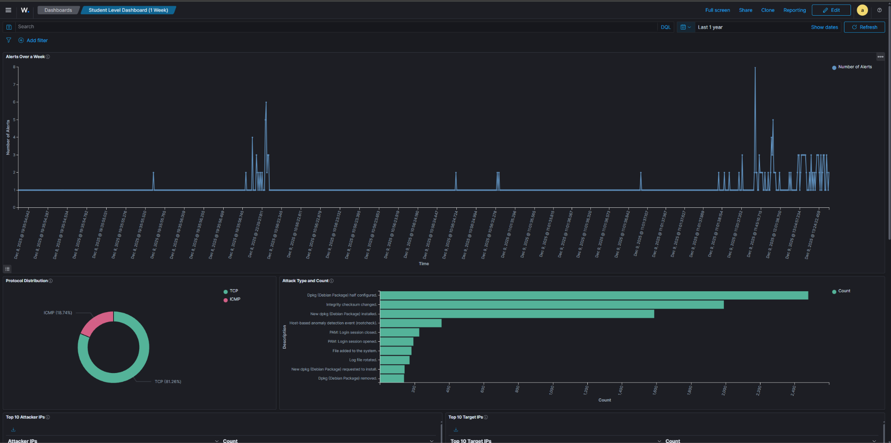

10.2 Suricata Dashboard
A custom Suricata dashboard was created in Wazuh / OpenSearch to visualize network-based detections generated by the Suricata NIDS. This dashboard is intended to show what types of suspicious network activity are being observed, which hosts are being targeted, and how alert volume changes over time.
Dashboard Name:
Suricata Overview
Index Pattern Used:
wazuh-alerts-*
Panels Included:
- Suricata Alerts
Donut chart showing the distribution of Suricata alert signatures. This panel summarizes the most common alert types captured by the sensor. Based on the current dashboard, example alert categories shown include scan activity, protocol anomalies, and stream-related issues.
- Suricata - Recent Alerts Table
Document table showing recent Suricata alert events. The table includes fields for time, source IP, destination IP, alert signature, severity, and signature ID. This panel acts as a live feed of recent Suricata detections and allows viewers to see specific alert events in detail.
- Suricata - Alert Severity Breakdown
Bar chart showing the number of alerts grouped by Suricata severity level. This panel helps distinguish lower-priority detections from more serious or noteworthy alerts.
- Suricata - Alerts Every Hour
Time-series line chart showing the number of Suricata alerts over time, grouped by hour. This panel is useful for identifying spikes in suspicious activity during attack demonstrations or testing.
- Suricata - Top 5 Targeted IPs
Table showing the IP addresses that received the most Suricata alerts, along with the corresponding alert counts. This panel helps identify which systems in the environment are being targeted most heavily.
Description:
This dashboard provides a focused view of the network-detection layer of the virtual SOC environment. Unlike the broader Wazuh dashboards, this dashboard is specifically centered on Suricata-generated alerts. It is useful for demonstrating how suspicious network traffic is identified as it moves through the lab environment. During testing and demonstrations, this dashboard helps show which alert signatures are firing, how severe the detections are, when activity spikes occur, and which systems are being targeted most often.
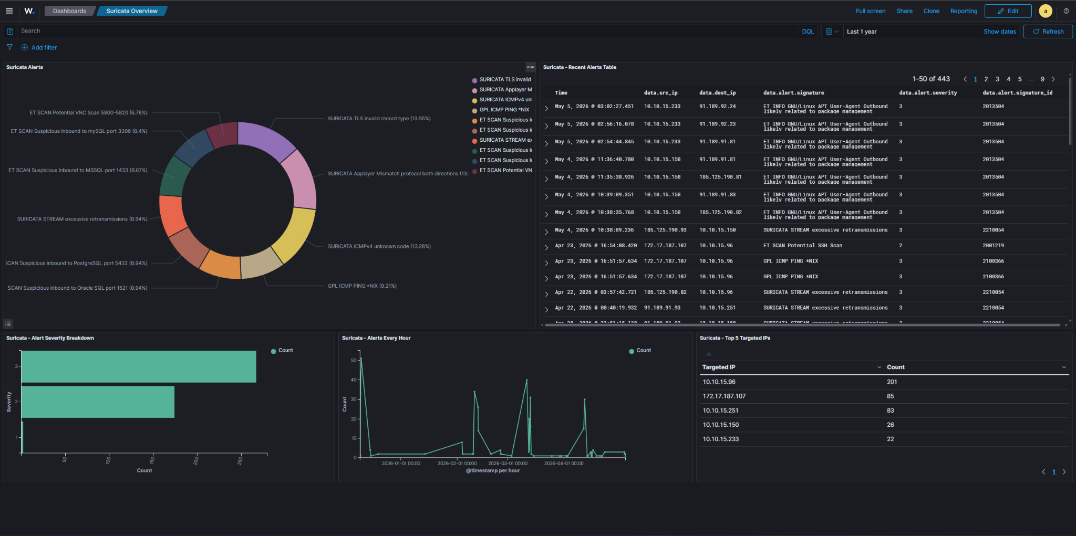

10.3 Honeypot Activity Dashboard
A custom Cowrie dashboard was created in Wazuh / OpenSearch to visualize honeypot telemetry collected from the decoy SSH environment. This dashboard is focused on showing attacker interaction with the honeypot, including login attempts, session activity, command execution, and overall attack volume over time.
Dashboard Name:
Cowrie
Index Pattern Used:
wazuh-alerts-*
Panels Included:
- Cowrie Recent Commands
Document table showing recent command input captured from Cowrie sessions. The table includes fields for time, source IP, and command input. This panel is useful for showing what actions an attacker attempted after connecting to the honeypot.
- Cowrie Event Types Count
Table showing the count of Cowrie event types observed in the dataset. Example event types shown in the current dashboard include cowrie.session.closed, cowrie.session.connect, cowrie.client.version, cowrie.command.input, cowrie.client.kex, cowrie.login.failed, cowrie.login.success, cowrie.client.size, and cowrie.client.var. This panel summarizes the types of activity being recorded by the honeypot.
- Cowrie Attack Volume Timeline
Time-series line chart showing the volume of Cowrie-related events over time. This panel helps visualize when attack activity increases and how active the honeypot is during a given period.
- Cowrie Login Attempts
Table showing login attempt combinations, including username, password, and count. This panel demonstrates the kinds of credentials attackers are trying against the honeypot and helps illustrate brute-force behavior.
- Cowrie Event Type Distribution
Donut chart showing the proportional breakdown of Cowrie event types. This provides a quick visual summary of the relative frequency of different honeypot events, such as session connections, failed logins, command input, and successful logins.
Description:
This dashboard provides a focused view of attacker behavior against the Cowrie honeypot. Unlike broader SOC dashboards, it is specifically designed to demonstrate how a decoy SSH system captures login attempts, session metadata, and attacker commands. It is particularly useful during live demonstrations because the information is easy to interpret visually and clearly shows how attackers interact with an exposed service.

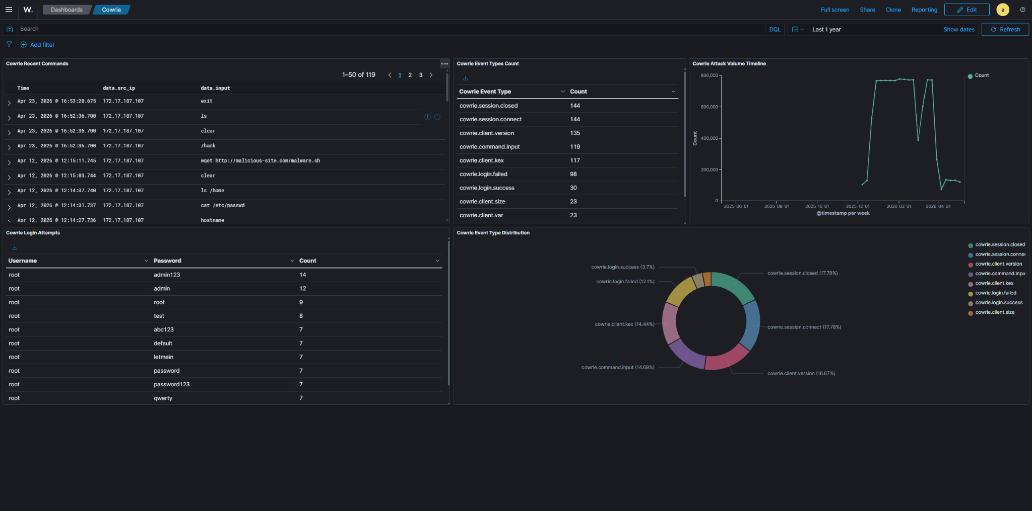

10.4 Proxmox Dashboard
Proxmox resource utilization is monitored primarily through the built-in Proxmox web interface. The Proxmox dashboard provides visibility into CPU usage, memory usage, storage usage, VM status, and node health.
Monitoring Approach:
Built-in Proxmox web UI
Items Monitored:
- Node CPU utilization
- Memory utilization
- Storage usage
- Virtual machine status
- Network activity
- Host uptime and general system health
Description:
The Proxmox interface is used to verify that the virtualization environment is healthy and that the virtual machines required for the vSOC environment are running correctly. This helps support both troubleshooting and live demonstrations by confirming that the underlying infrastructure is functioning as expected.

11. Detection Use Cases
This section documents specific attack scenarios tested in the vSOC and the resulting detections observed across Wazuh, Suricata, and Cowrie.

11.1 Use Case: EternalBlue / MS17-010
Field | Details
Attack Vector | Metasploit ms17_010_eternalblue from Kali (172.26.1.x) to Metasploitable3-Win (172.26.1.13)
MITRE Technique | T1210 — Exploitation of Remote Services

11.2 Use Case: SSH Brute Force (Honeypot)
Field | Details
Attack Vector | Hydra / automated scanner targeting Cowrie SSH honeypot
MITRE Technique | T1110 — Brute Force
Wazuh Alert ID(s) | [ Rule IDs ]
Suricata Alert | [ Signature / SID ]
Cowrie Events | [ Login attempts, commands captured ]

12. Network Topology

12.1 Logical Network Diagram

https://chunk-trass-27815951.figma.site/

13. Credentials & Access Management
IMPORTANT: Do not store plaintext credentials in this document if it will be shared publicly. Reference a secure credential store (e.g. Bitwarden, local KeePass, or team password manager) instead.

13.1 Credential Inventory
System | Username
Proxmox Web UI | root
OPNsense Web UI | root / admin
Wazuh Dashboard | admin
Metasploitable3 Win | vagrant
Metasploitable3 Linux | vagrant
Cowrie (fake shell) | root

14. Lessons Learned & Future Work

14.1 Challenges Encountered
Major challenges centered on networking, log forwarding, and service integration. Early development in OpenStack required significant work around routing, subnetting, DNS resolution, and interface mapping before traffic flowed correctly through pfSense. After moving to Proxmox, infrastructure management became simpler, but internal access still required careful WAN/LAN separation and jump-host style access for LAN systems.
Forwarding Suricata EVE JSON alerts from pfSense into Wazuh was another major challenge. This required configuring syslog-ng, resolving conflicts with the default pfSense logger, and stabilizing the custom forwarding configuration so it would persist across restarts.
Wazuh agent deployment was generally successful, but enrollment and service startup sometimes required manual validation and troubleshooting before agents consistently reported to the dashboard.

14.2 What Worked Well
The final architecture worked well once the core networking and logging issues were resolved. pfSense provided a strong routing and firewall layer, Suricata reliably detected scan and test-rule traffic crossing the network, and Wazuh provided centralized alerting, endpoint visibility, and dashboarding in a single platform.
Cowrie was also highly effective for demonstrations. Running the honeypot on port 22 while moving real SSH to port 22022 allowed attacker activity to be captured safely, including credentials, commands, downloads, and session metadata, without exposing the real host to direct compromise.
Proxmox proved to be a better long-term fit for the project’s current teaching use case because it offers simpler infrastructure management, direct console access, and clearer host/network administration for a smaller-scale lab environment.

14.3 Future Improvements
- Add more VMs and Wazuh agents to simulate additional attack paths and more realistic multi-host scenarios.
- Expand endpoint diversity with additional Linux and Windows systems for broader detection coverage.
- Further simplify routing and remove special-case network workarounds where possible.
- Harden pfSense-to-Wazuh log forwarding so it is easier to maintain and reproduce.
- Add more automated attack scripts and validation workflows for repeatable classroom demos.
- Expand honeypot and vulnerable-host coverage to demonstrate more post-compromise and lateral movement activity.
- Further implement penetration testing AI agents

15. References & Resources

15.1 Documentation Links
- Wazuh Documentation: https://documentation.wazuh.com
- Cowrie Documentation: https://cowrie.readthedocs.io
- Suricata Documentation: https://docs.suricata.io
- OPNsense Documentation: https://docs.opnsense.org
- Proxmox Documentation: https://pve.proxmox.com/wiki
- Terraform Proxmox Provider: https://registry.terraform.io/providers/Telmate/proxmox
- Metasploitable3 Repo: https://github.com/rapid7/metasploitable3

15.2 Project Repository

https://gitlab.csi.miamioh.edu/2026-senior-design-projects/virtual-soc-environment/virtual-soc-environment

15.3 Expo Presentation

https://youtu.be/UL10BeYUQMc

Miami University vSOC — Confidential Lab Documentation

